2 Assignment

1. List 3 real-world devices in your home or college that use SMPS (Switched Mode Power Supply) and 2 devices that use UPS (Uninterruptible Power Supply), explaining in one line why each device needs that type of power supply.

Device | Power Supply | Why It Needs It
Desktop Computer | SMPS | Converts AC power into stable DC power for PC components.
LED Monitor | SMPS | Provides the required low-voltage DC power efficiently.
Wi-Fi Router | SMPS | Converts AC power to safe DC power for the router.
Desktop Computer | UPS | Provides backup power during power cuts and prevents sudden shutdown.
CCTV System | UPS | Keeps the cameras and recording system running during power failures.

2. Draw and label a diagram showing the main internal components of a typical SMPS unit found in a desktop PC, including AC input, rectifier, transformer, and DC output sections.<br><br><em><strong>Hint:</strong> You can hand-draw and upload a photo, or use any free diagram tool like draw.io.</em>

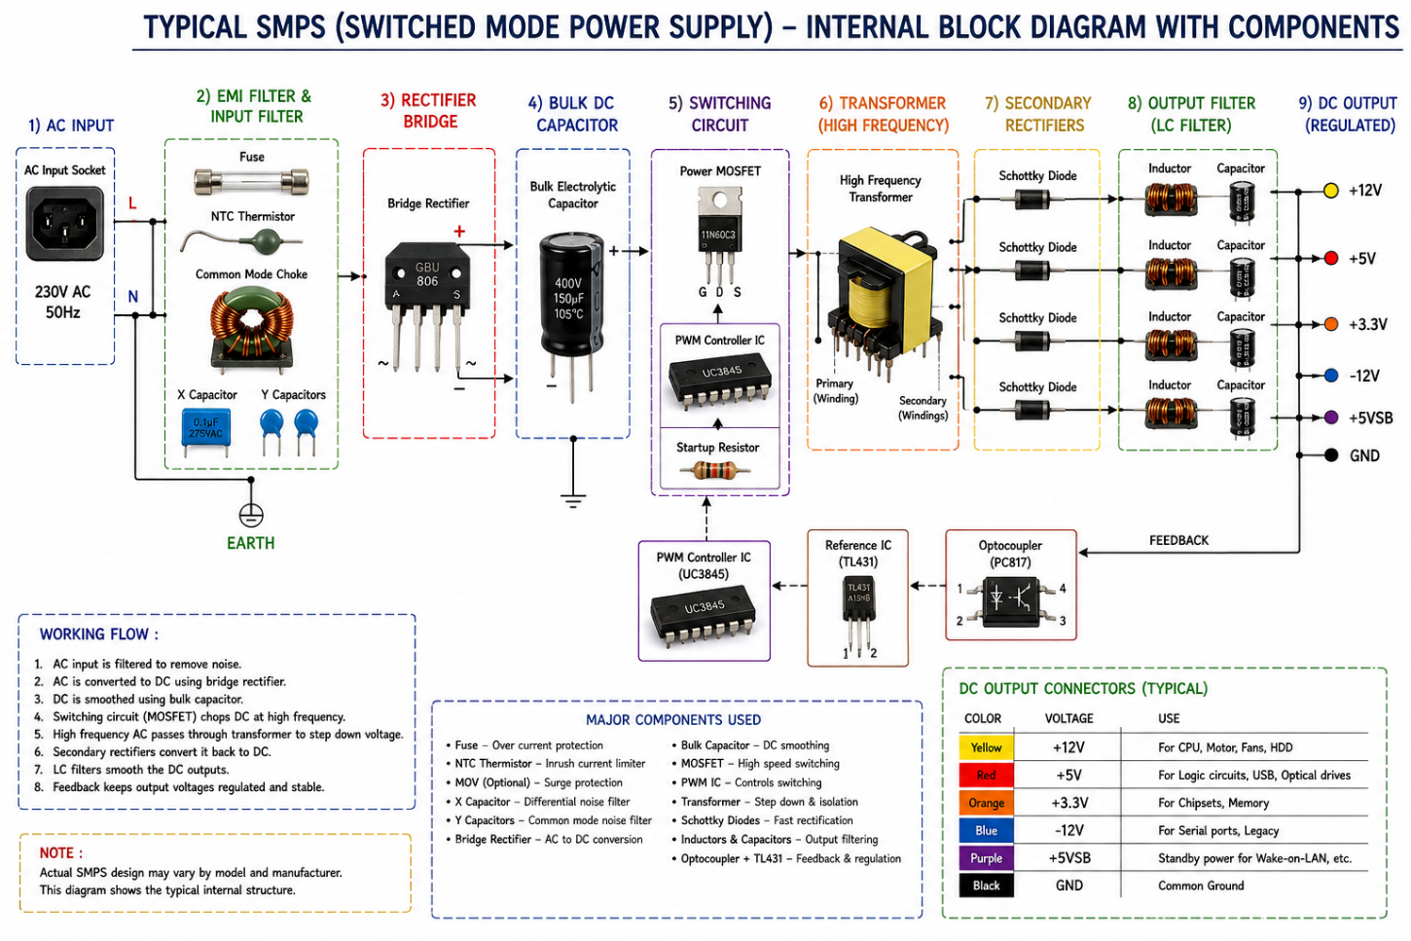

3. Take photos or find clear images online of the following power connectors: ATX 24-pin motherboard connector, SATA power connector, Molex connector, and PCIe 6/8-pin connector. For each, write its name, the devices it powers, and one safety tip for connecting/disconnecting it.

PC Power Connectors
1. ATX 24-Pin
- Devices It Powers: Motherboard
- Safety Tip: Turn off and unplug the PC before connecting or disconnecting it.
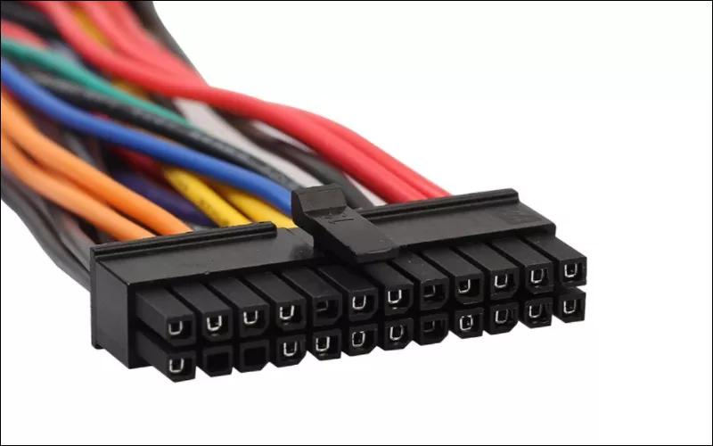
2. SATA Power
- Devices It Powers: HDD, SATA SSD, optical drives
- Safety Tip: Do not force the connector; align it correctly before inserting.
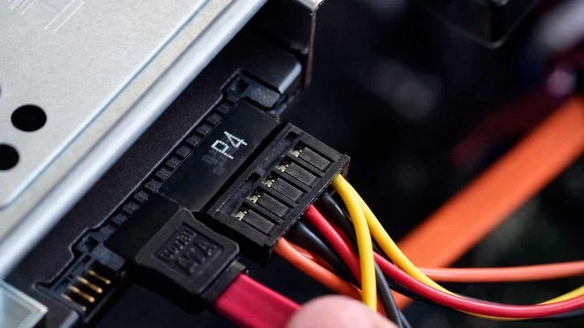

3. Molex 4-Pin
- Devices It Powers: Case fans and older drives
- Safety Tip: Disconnect the power before removing the connector.
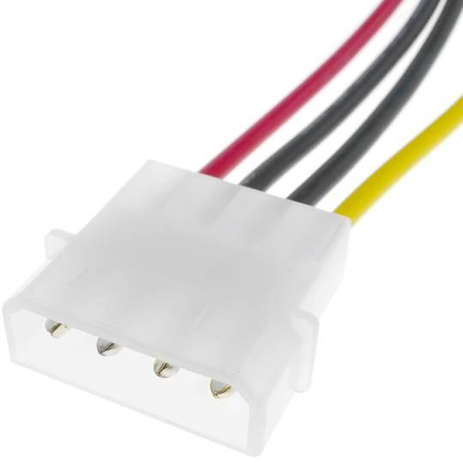
4. PCIe 6/8-Pin
- Devices It Powers: Dedicated graphics card (GPU)
- Safety Tip: Make sure the connector is fully locked before powering on the PC.
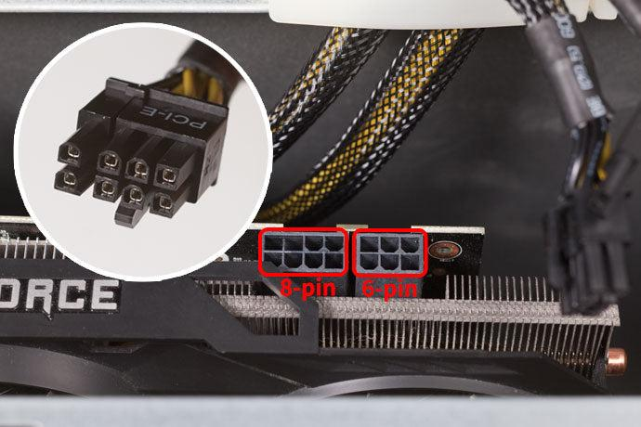
5. SATA Power Connector
- Connector: 15-pin SATA power connector.
- Safety Tip: Turn off and unplug the PC before connecting or disconnecting it, and do not force the connector.
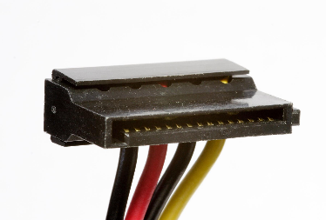
4. Imagine you are setting up a new gaming PC. List the steps you would follow to connect the SMPS to the motherboard, graphics card, and storage devices, mentioning which specific cables and connectors are used for each.

Steps to Connect SMPS to a Gaming PC
Step 1: Connect SMPS to Motherboard
Connect the 24-pin ATX power cable from the SMPS to the motherboard’s 24-pin power connector.
Step 2: Connect CPU Power
Connect the 4/8-pin EPS CPU power cable from the SMPS to the CPU power connector near the CPU socket.
Step 3: Connect SMPS to Graphics Card
Connect the PCIe 6-pin, 8-pin, or 6+2-pin cable from the SMPS to the GPU.
Step 4: Connect Power to HDD/SSD
Connect the 15-pin SATA power cable from the SMPS to the HDD or SATA SSD.
Step 5: Connect Other Devices
If required, connect SATA power or Molex cables to compatible fans or other devices.
Step 6: Check All Connections
Make sure every connector is properly inserted and locked before turning on the PC.

